## 20220817-

<https://www.cambly.com/api/chats/62fcd81c0e4460d09aa4b9a1/video>

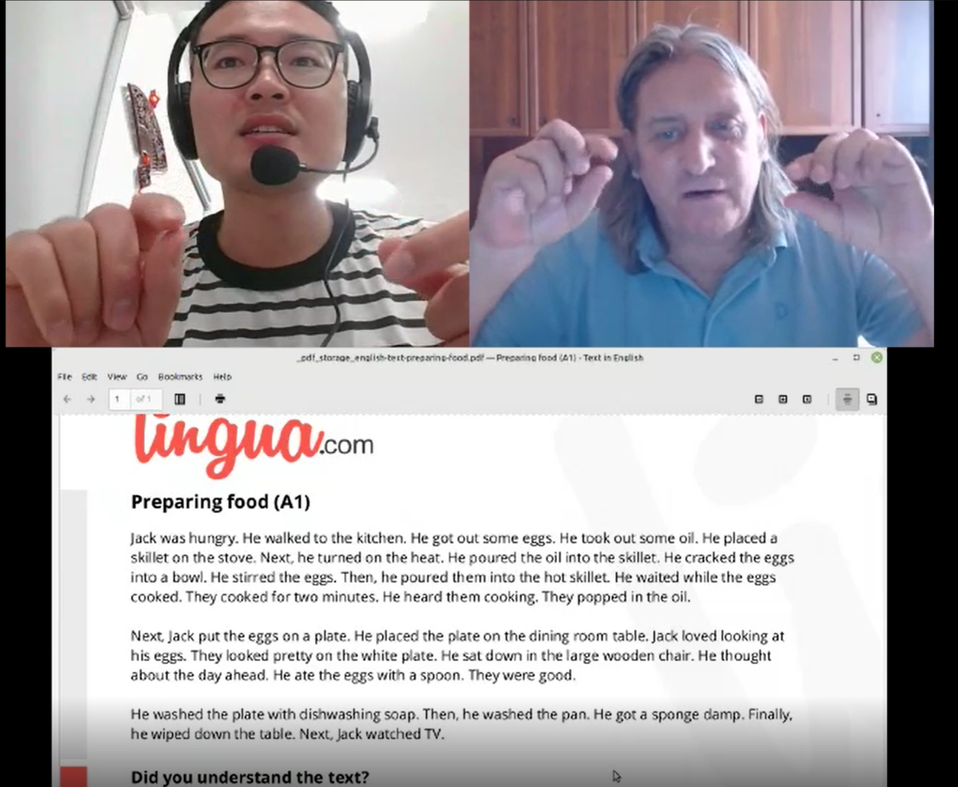

|  |  |  |  |
| --- | --- | --- | --- |
|  |  |  | |
| 1. reading | | (2)reading | |
| document |  | ride the bike | /raɪd/ |
| kitchen |  | and an apple |  |
| closet | ˈklɒzɪt xi 壁橱 | bed  egg | /bed/ |
| did you  dead | /dɪd/  /ded/ | soup | u: |
|  |  | sandwich | ˈsænwɪt |

|  |  |  |  |
| --- | --- | --- | --- |
|  |  |  |  |
| (3)reading | |  |  |
| preparing | i | stirred the eggs | stɜːd 搅动 |
| oil | ɔɪl | cooked | t |
| skillet  pan | skɪlɪt/ 平底锅 | The eggs popped in the oil. | 鸡蛋在煎油内滋滋响 |
| heat | hiːt/ 热源 gas | plate | /pleɪt/ |
| cracked | Krækt 破裂；砸开 | spoon | /spuːn/ 勺子 |
| Soap | səʊp/ 肥皂 | sponge damp | spʌndʒ/ /dæmp/  海绵 超时 |
| watched TV | t | concentrating on | /ˈkɒnsntreɪtɪŋ/ 专注 |

|  |  |  |  |
| --- | --- | --- | --- |
|  |  |  |  |
| (4)reading | |  |  |
| celebrate vacation  holiday | veɪˈkeɪʃn | dolphin |  |
| Florida | ˈflɒrɪdə | whales | /weɪlz/ |
| sandcast |  | penis | Male body feature |
| sailboat | /ˈseɪlbəʊt/ 帆船 | palm trees | pɑːm/ 棕榈树 |
| special | ˈspeʃ(ə)l/ | surfer | /ˈsɜːfə(r)/ |

|  |  |  |  |
| --- | --- | --- | --- |
|  |  |  |  |
| (5)reading | |  |  |
| mathematics | ˌmæθəˈmætɪks | Also / always |  |
| Ma-the-ma-tics |  | on the weekends | ˌwiːk'endz |
| nurse | /nɜːs/ |  |  |
| hospital | /ˈhɒspɪt(ə)l/ |  |  |
| nervous | /nɜːvəs/ 紧张  ˈdʒɪtəri |  |  |

|  |  |  |  |
| --- | --- | --- | --- |
|  |  |  |  |
| (6)reading | |  |  |
| Tongue Twister | /tʌŋ /ˈtwɪstə(r)/  舌头 旋转 -绕口令 | cricket critic | /ˈkrɪkɪt /ˈkrɪtɪk/  板球 评论家 |
| these | /ðiːz/ | proper  copper | ˈprɒpə(r)/真正的 /ˈkɒpə(r)/ 紫铜色的 |
| bold | bəʊld/ | napkins | ˈnæpkɪnz 餐巾纸  Paper which use to clean your mouth |
| Bald  gene  testerone | bɔːld 秃头  基因  睾丸酮 | thrush | /θrʌʃ/ 画眉 |
| Back brake  Broke | Breɪk 刹车 /brəʊk/ | fly  flea | /flaɪ/ 蝇子  /fliː/ 跳蚤 |
|  |  | flew  flue | /fluː/飞翔  /fluː/ 烟道；暖气管 |

## Reading

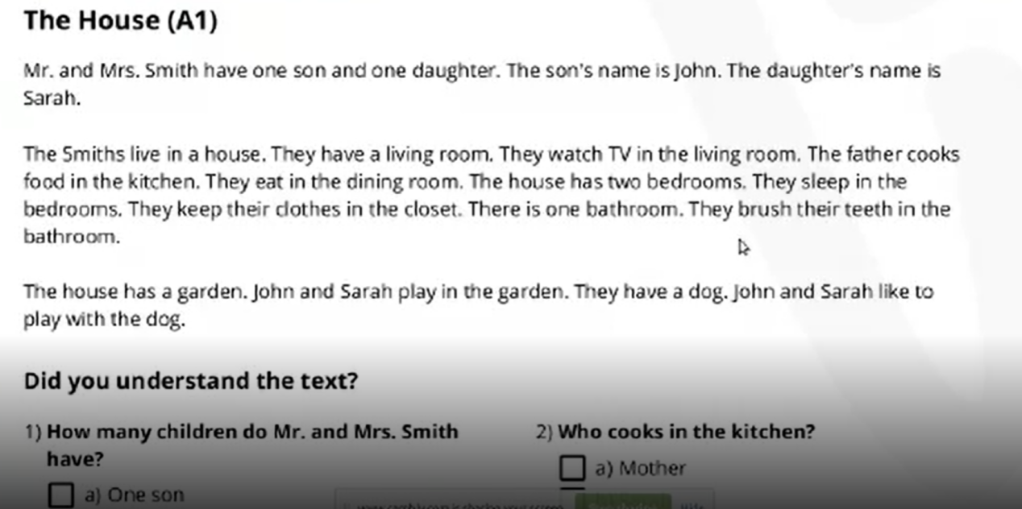

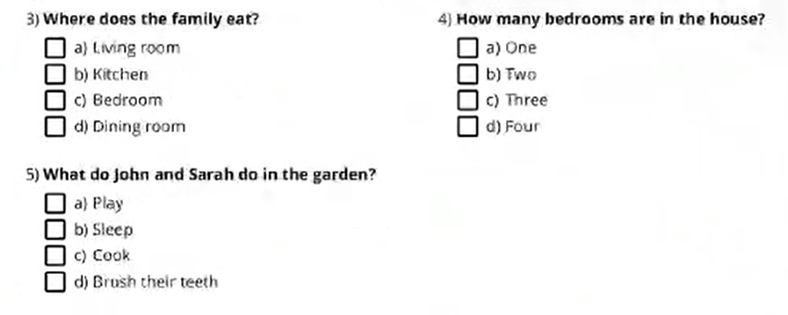

|  |  |
| --- | --- |
|  |  |
| 1. reading | |
| document |  |
| kitchen |  |
| closet | ˈklɒzɪt xi 壁橱 |
| did you  dead | /dɪd/  /ded/ |
|  |  |

## Reading

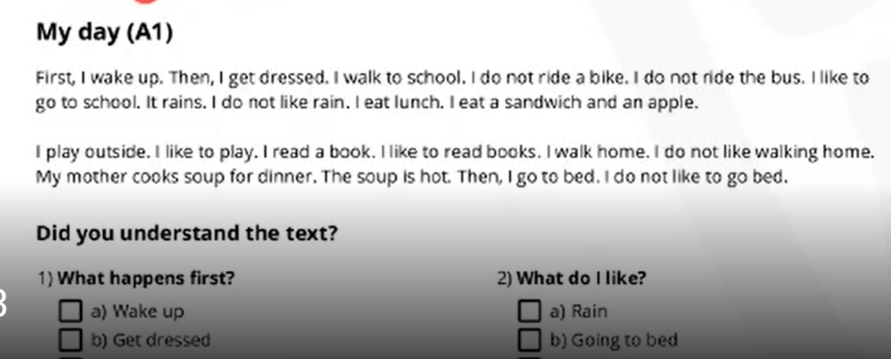

|  |  |
| --- | --- |
|  |  |
| (2)reading | |
| ride the bike | /raɪd/ |
| and an apple |  |
| bed  egg | /bed/ |
| soup | u: |
| sandwich | ˈsænwɪt |

## Reading

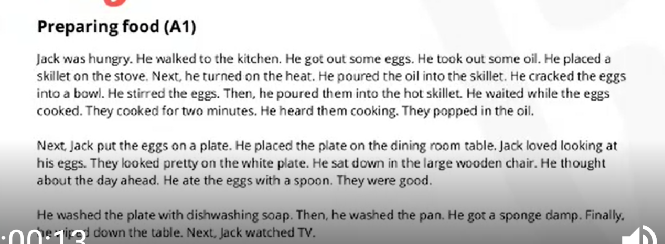

|  |  |  |  |
| --- | --- | --- | --- |
|  |  |  |  |
| (3)reading | |  |  |
| preparing | i | stirred the eggs | stɜːd 搅动 |
| oil | ɔɪl | cooked | t |
| skillet  pan | skɪlɪt/ 平底锅 | The eggs popped in the oil. | 鸡蛋在煎油内滋滋响 |
| heat | hiːt/ 热源 gas | plate | /pleɪt/ |
| cracked | Krækt 破裂；砸开 | spoon | /spuːn/ 勺子 |
| Soap | səʊp/ 肥皂 | sponge damp | spʌndʒ/ /dæmp/  海绵 超时 |
| watched TV | t | concentrating on | /ˈkɒnsntreɪtɪŋ/ 专注 |

## Reading

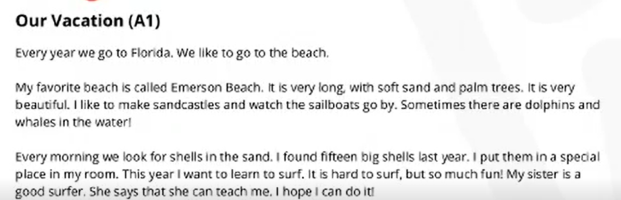

|  |  |  |  |
| --- | --- | --- | --- |
|  |  |  |  |
| (4)reading | |  |  |
| celebrate vacation  holiday | veɪˈkeɪʃn | dolphin |  |
| Florida | ˈflɒrɪdə | whales | /weɪlz/ |
| sandcast |  | penis | Male body feature |
| sailboat | /ˈseɪlbəʊt/ 帆船 | palm trees | pɑːm/ 棕榈树 |
| special | ˈspeʃ(ə)l/ | surfer | /ˈsɜːfə(r)/ |

## Reading

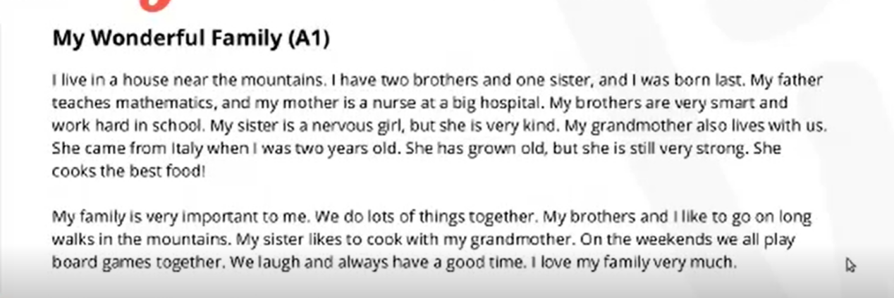

|  |  |  |  |
| --- | --- | --- | --- |
|  |  |  |  |
| (5)reading | |  |  |
| mathematics | ˌmæθəˈmætɪks | Also / always |  |
| Ma-the-ma-tics |  | on the weekends | ˌwiːk'endz |
| nurse | /nɜːs/ |  |  |
| hospital | /ˈhɒspɪt(ə)l/ |  |  |
| nervous | /nɜːvəs/ 紧张  ˈdʒɪtəri |  |  |

## Reading

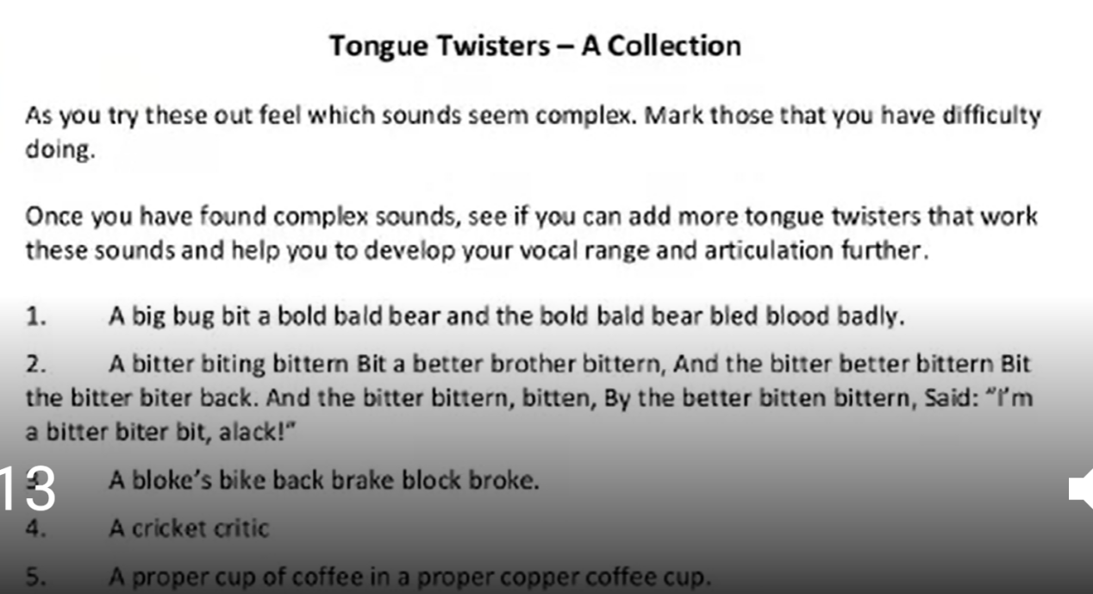

|  |  |  |  |
| --- | --- | --- | --- |
|  |  |  |  |
| (6)reading | |  |  |
| Tongue Twister | /tʌŋ /ˈtwɪstə(r)/  舌头 旋转 -绕口令 | cricket critic | /ˈkrɪkɪt /ˈkrɪtɪk/  板球 评论家 |
| these | /ðiːz/ | Proper  copper | ˈprɒpə(r)/真正的 /ˈkɒpə(r)/ 紫铜色的 |
| bold |  | napkins | ˈnæpkɪnz 餐巾纸  Paper which use to clean your mouth |
| Bald  gene  testerone | bɔːld 秃头  基因  睾丸酮 | thrush | /θrʌʃ/ 画眉 |
| Back brake  Broke | Breɪk 刹车 /brəʊk/ | fly  flea | /flaɪ/ 蝇子  /fliː/ 跳蚤 |
|  |  | flew  flue |  |



## 20220816

https://www.cambly.com/api/chats/62fb85c1006d3e864c340418/video

<https://www.cambly.com/api/chats/62fb8a93edde6ce91d078589/video>

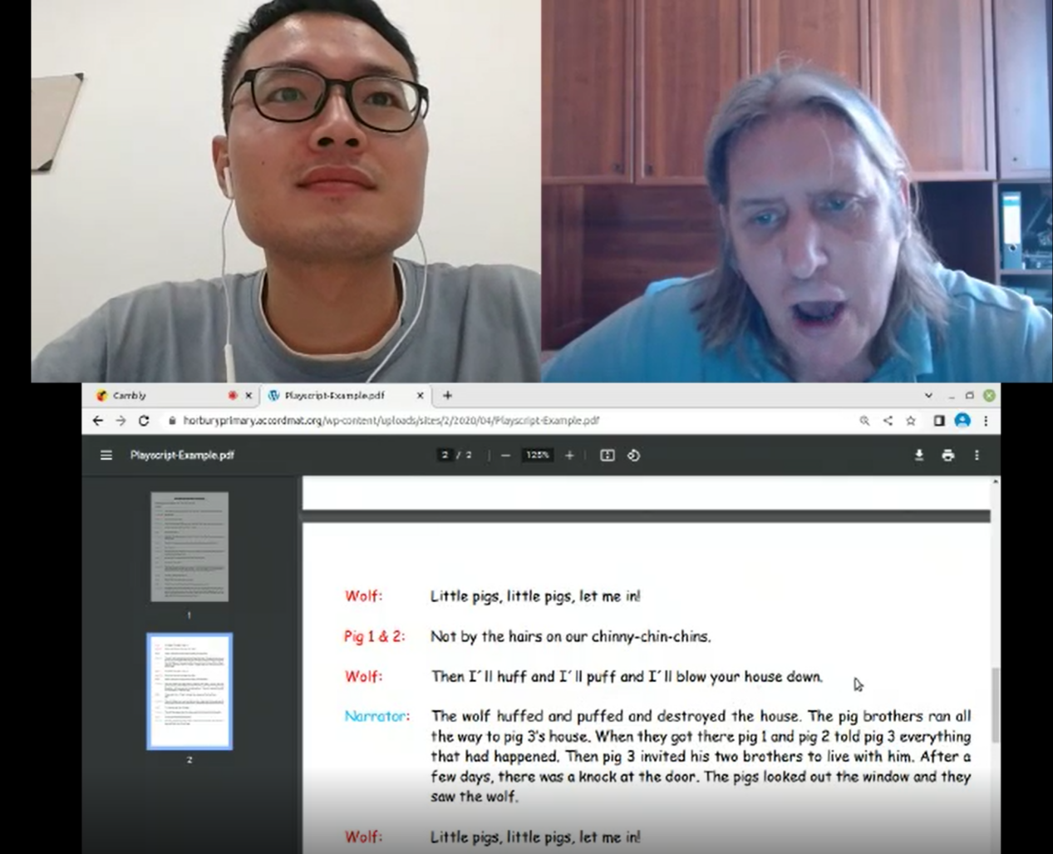

|  |  |
| --- | --- |
| Word | Pronounce / pho-ne-tic sym-bol |
| narrator | /nəˈreɪtə(r)/ 解说 |
| might, met,egg,sell | maɪt/  /met /sel/ |
| Knock  know | /nɒk/ kn |
| Puff  poof | pʌf/ 吹吸，抽（烟、烟斗等）；吹，喷 smoke  /pʊf/ 吹熄蜡烛的声音 |
| fair  fire | feə(r)/ 公平的  /ˈfaɪə(r) |
| peck  piper i e  pick  Peter  pickled | /pek/ 啄食  /ˈpaɪpə(r)/ 吹奏，胡椒 /pɪk/ 采摘 /ˈpiːtə(r)/  /ˈpɪkld/ pick lld |
| straw | /strɔː/ 干草 |
| Huff | 生气地说；把……吹胀，吹气；发 |
| Chimney  Roof / | tʃɪmni/ 烟筒  ruːf/ 屋顶 |

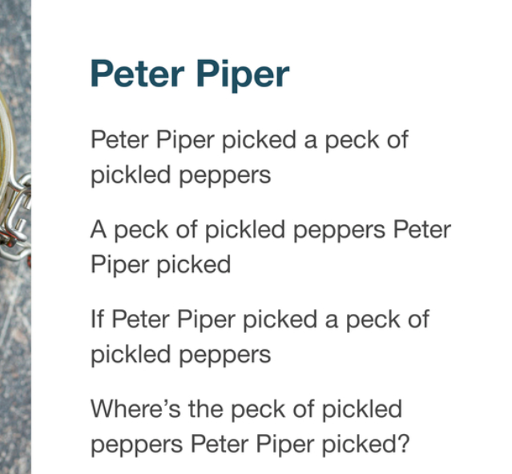

wolf and three pigs script

https://horburyprimary.accordmat.org/wp-content/uploads/sites/2/2020/04/Playscript-Example.pdf

